package brad;

public class Brad {

public static void main (String[] args) {

char ch = '*';

char cn = '^';

int m = 0;

char a = '|';

System.out.format("%50c%n%49c%c%c%n%47d%c%c%c%c%c%n%47c%c%c%c%c%c%c%d%n%46c%c%d%c%c%c%c%c%c",ch,ch,ch,ch,m,ch,cn,ch,ch,ch,ch,ch,ch,cn,ch,ch,ch,m,ch,ch,m,ch,ch,cn,ch,ch,ch);

System.out.format("%n%45c%c%c%c%c%c%c%c%c%c%d%n%44c%d%c%c%c%c%d%c%c%c%c%c%c",ch,ch,ch,ch,ch,ch,ch,cn,ch,ch,m, ch,m,ch,ch,ch,ch,m,ch,ch,cn,ch,ch,ch );

System.out.format("%n%49c%c%c%n",a,a,a);

System.out.format("%42c",ch);

System.out.println("Merry Christmas!" + "*");

}

}

*

***

0*^***

***^***0

**0**^***

*******^**0

*0****0**^***

|||

*Merry Christmas!*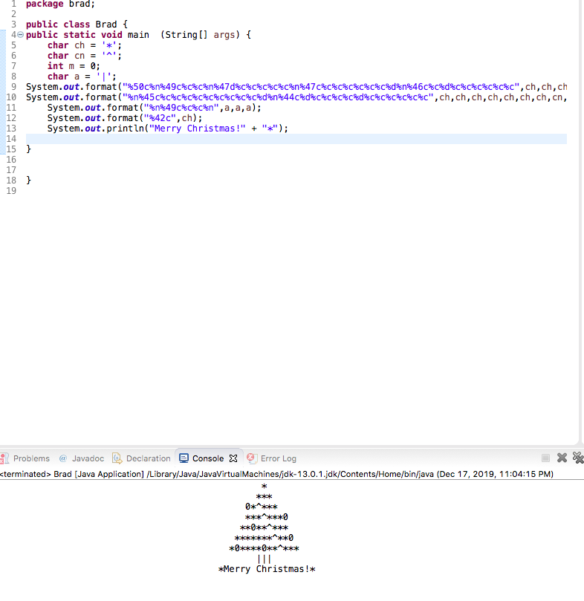

**Așa s-a primit în Java**